**Assignment 1 Day 3**

1. Create a blank file named "myfile"

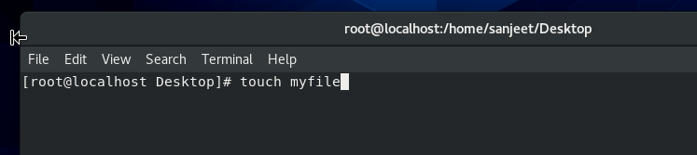**touch myfile**

1. Open "myfile" in vi editor

**Vi /home/sanjeet/Desktop/myfile**

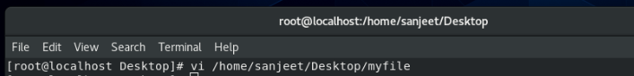

1. Write your name, address, email id, phone number and blood group in 5 different lines

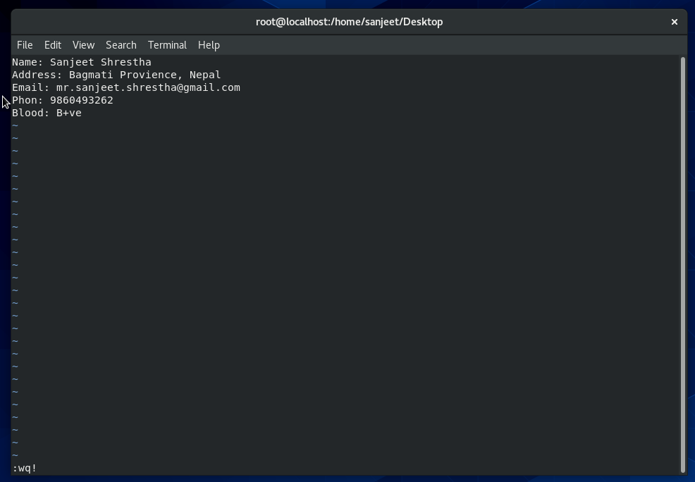

1. Build one single expression to see the line with your name and blood group in myfile

**egrep '(Name|Blood)' myfile**

